**Commentary Planning Sheet Economics IB**

The overall aim is to use your economics knowledge to explain an event or change in the world around us.

Title of Article: **China’s Cheap Steel Hurts Latin America’s Industry**

Source: <https://dialogo-americas.com/articles/chinas-cheap-steel-hurts-latin-americas-industry/>

Date: **07/01/2024**

Key concept: **Change**

Terms in the article or related to the article that would require definition:

1. Trade Protection: Government intervention aiming to limit imports and/or encourage exports by setting up trade barriers that protect from foreign competition.
2. Tariff: A tax that is placed on imports to protect domestic industries from foreign competition and to raise revenue for the government

What change/policy is discussed in the article?

Many Latin American countries are imposing tariffs on China's cheap steel. The quantity of steel produced in China is larger than its domestic demand, due to the slowdown of China’s real estate and construction business, leaving producers dependent on other countries to make up the shortfall. In addition, the exportation subsidy imposed by Chinese government during the pandemic has further increased the wave of cheap Chinese steel to spread around the world. The dumping have resulted in deindustrialization in Latin American countries and therefore they need to impose trade protection

What diagram(s) could you draw and explain to illustrate this change? Sketch them. Often the first diagram will illustrate a problem, while the second diagram will show the suggested policy solution.

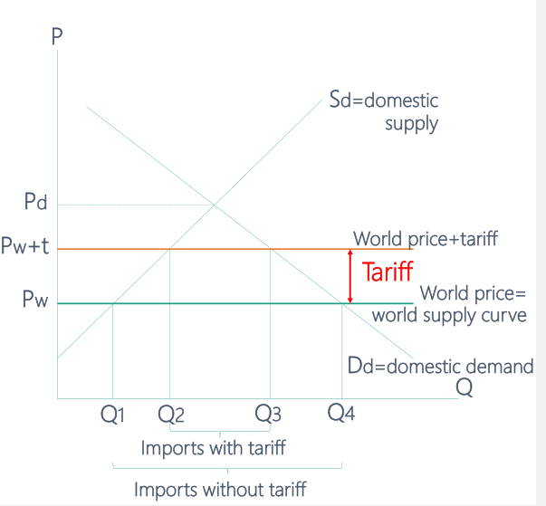

Now, evaluate this change. If there is a policy solution, is it likely to solve the problem? What are the likely effects, both positive and negative, or on various stakeholders? If you can, rank the impacts from biggest to least, with reasons. Lastly, for the best sort of evaluation, how does this instance reflect on economic theory itself? Does what happened or what is suggested in your news article accord with what economic theory suggests should happen? If not, why not?

Policy effect: the price of steel imported from China becomes higher, therefore reduce the import and protect domestic industry. However, China have put on retaliations for some countries by banning imports from them.

**Advantages of Imposing Tariffs**

1. **Protection of domestic industries & jobs:** Tariff can help shield local producers from the influx of cheap steel that has been driving them out of business. (“Chile’s Compañía de Aceros del Pacífico (CAP) …The company resumed activities after the government imposed a temporary tariff on Chinese steel imports”) This also created a derived demand for labor in China rather than their own, therefore cause a **change** in job positions, creating job loss and negative impacts on standards of living of households in an economy (“putting at risk 1.4 million jobs in the steel sector; forcing the suspension of operations of several companies and massive layoffs”). By imposing tariff, domestic production can be increased thus **change** the current employment issue.
2. **Protection of the environment**: The low price of steel imported from China is purely based on their subsidization in the steel industry and excess supply, while the production of steel in China also creates a higher carbon emission, result in a negative **change** inthe environment. (“While Latin American steel mills emit 1.55 tons of carbon dioxide (CO2) per ton of steel produced, China emits 2.24 tons of CO2, which represents 45 percent more pollution.”). By imposing the tariff and reduce the steel imported from China, the environment can be better protected with less carbon emission.
3. **Encouraging fair competition and refuse dumping**: Tariffs can level the playing field, allowing local industries to compete more fairly against subsidized foreign products, **changing** the current unfair dumping market. (We have been enduring unfair competition for two years through massive imports from China and Russia at predatory prices, even 40 percent below international and market prices,” Fabio Galán, president of Acerías Pazdelrío, told daily *El Colombiano*.)

**Disadvantages of Imposing Tariffs**

1. **Risk of trade retaliation**: As Latin American impose their tariff to **change** the dumping situation, China may retaliate by imposing their own barriers. Tariffs could provoke retaliatory measures from China, as seen in the past when China banned soy-based products from Argentina following anti-dumping measures. Such actions could **change** the relationship between China and Latin America countries, escalate trade tensions and disrupt other sectors of the economy that rely on trade with China. (“China’s coercive diplomacy…China banned soy-based products from Argentina in 2016 in response to far-reaching anti-dumping measures, Argentine daily *La Nación* reported. In 2019, following the arrest of a Huawei executive in Vancouver, China suspended all purchases of Canadian canola seed, *AP* reported.”) With a decrease in export, Latin American countries may have their real GDP lowered.
2. **Increased cost of production** : While tariffs may protect domestic industries, they can also lead to higher steel prices for consumers and other industries reliant on steel. This **change** in steel import affects steel price could ultimately hurt the economy and lead to inflationary pressures. (“even 40 percent below international and market prices,”)
3. **Misallocation of resources**: in trade protection, while trying to protect the domestic product by **changing** the tariff, the allocation of resources **changes** to a misallocated situation on a global scale, as the production moves away from the lowest cost producers in other countries to higher cost domestic producers. (“40 percent below international and market price”)

***China’s Cheap Steel Hurts Latin America’s Industry***

*BY Diálogo*

***July 01, 2024***

The Latin American steel industry is facing a crisis due to China’s unfair trade practices, which flooded the market with cheap steel, threatening regional producers’ jobs and livelihood, *Radio France International* reported.

“China’s production affects Latin American economies, putting at risk 1.4 million jobs in the steel sector; forcing the suspension of operations of several companies and massive layoffs,” Gabriela Fajardo Mejía, an expert in international relations and doctoral candidate in Global Society Law at the University of Navarra in Spain, told *Diálogo*on May 28. “[Production] is not subjected to environmental and quality standards. Chinese companies do not comply with rules of transparency and regulations.”

China’s strategy of selling its product below market prices has triggered a dumping situation that severely affects Latin America. According to data from the World Steel Association, China’s share of global crude steel production reaches 54 percent. Between January and April 2024 alone, China produced 343.7 metric tons of steel.

“The slowdown in China’s real estate and construction business caused domestic demand for steel to decline, leaving producers dependent on other countries to make up the shortfall,” Henry Ziemer, research associate with the Americas Program at the Center for Strategic and International Studies, told*Diálogo*. “As the U.S. market looks increasingly unfavorable for Chinese steel producers, they are now looking to Latin American countries with fewer trade barriers to get rid of excess capacity.”

In addition, the Chinese government subsidized steel production and exports during the pandemic. This caused a wave of cheap Chinese steel to spread around the world, Colombian newspaper *El Tiempo* reported.

Mexico, Chile, and Brazil have significantly increased tariffs on steel imports from China to protect domestic companies, with other countries in the region likely to follow suit.

Cheap Chinese steel is sinking the Latin American steel industry, causing several of the region’s large companies to freeze or shut down operations, the Latin American Steel Association (Alacero) said in a statement. For Alejandro Wagner, Alacero executive director from June 1, 2021 to June 1, 2024, the situation is creating a “process of deindustrialization in the region,” he told *BBC*.

In March, Chile’s Compañía de Aceros del Pacífico (CAP) suspended operations at its emblematic Huachipato industrial plant, citing its inability to compete with Chinese prices, and stressing that China’s dumping has affected the economic and social development of the region.  The company resumed activities after the government imposed a temporary tariff on Chinese steel imports. The Huachipato’s board of directors expressed hope that the measure would become definitive.

Similarly in Colombia, the steel industry is asking for fair competition, as they experience the devasting rippling economic effects. “We have been enduring unfair competition for two years through massive imports from China and Russia at predatory prices, even 40 percent below international and market prices,” Fabio Galán, president of Acerías Pazdelrío, told daily *El Colombiano*.

“In the past there have been reports that iron ore mines in Mexico, raided by organized crime cartels, played an important role in shipping looted iron ore to China, which was then converted into steel,” Ziemer said. “These reports provide additional evidence that China’s unfair and opaque trade practices create perverse incentives within the hemisphere, which can encourage criminal organizations and undermine the quality of governance.”

Brazilian steel producer Gerdau announced in March that it would temporarily lay off workers at its São José dos Campos plant, in São Paulo, blaming it on China’s unfair competition. Gustavo Werneck, president of the company, told the Brazilian media *InfoMoney* that these measures are only the first step to contain the Chinese surge.

“In addition, China subsidizes its companies in the sector, which allows lowering their costs. It is mainly worrying that quality and environmental standards for this production are not a factor taken into account by the Chinese government, but it is even more worrying that they are not a factor to be considered by steel buyers in Latin American countries, who to the detriment of their own local industry are mainly influenced by the low price,” Fajardo Mejía said. “While Latin American steel mills emit 1.55 tons of carbon dioxide (CO2) per ton of steel produced, China emits 2.24 tons of CO2, which represents 45 percent more pollution.”

The imposition of tariffs on China’s steel as a response to its unfair practices also underscore the potential for trade tensions between the Latin American countries and China, with a potential for retaliation from the Asian country, known for its coercive diplomacy.

For instance, China banned soy-based products from Argentina in 2016 in response to far-reaching anti-dumping measures, Argentine daily *La Nación* reported. In 2019, following the arrest of a Huawei executive in Vancouver, China suspended all purchases of Canadian canola seed, *AP* reported.

“China produces more steel than the next nine steel-producing countries combined, giving it a powerful tool to influence prices and disrupt local economies,” Ziemer said. “However, the fact that this latest round has targeted countries like Chile and Mexico may present an opportunity for the United States to coordinate with Latin American countries on ways to mitigate China’s unfair trade practices and protect their domestic industries.”